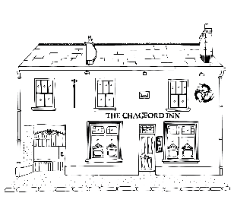
THE CHAGFORD INN
CHAGFORD ▪ DEVON

Starters/Light Bites
Mixed Olives £5 Nocellara Olives £5
Pickled Padron Peppers £5 Garlic and Rosemary Nuts £2
Homemade Focaccia, Whipped Smoked Butter £4.50
Home Cured Prosciutto £6

Soup of the Day with Focaccia |£6.95 V
Creamy Garlic Forest Fungi Wild Mushrooms on Toast| £9.95 V
Mackerel Pate, Rye Cracker, Pickled Cucumber | £8.95

Pub Classics
Helford Blue, Walnut and Spiced Pear Risotto|£14.95 V

Pasture Fed Beef Burger, Red Onion Jam, Denhay’s Bacon, Cornish Yarg, Pretzel Roll, Fries| £17.95

Confit Leg of Sladesdown Duck, Lentils, Carrot £18.95

Ashridge Beef Shin Ragu. Soft Polenta, Parmesan | £16.95
Ciabattas and Rolls
(AVAILABLE 12-3PM ONLY)

Served with Dressed Salad Leaves and Slaw
Brie and Red Onion Jam £7.95 V
Denhay’s Streaky Bacon, Tomato and Lettuce £7.95
Home Smoked Pastrami Rueben £10.95

